**Computer Network**

Message **signal:**

t=0:.001:1;

% Plot sine and cosine graph

a=input("Enter the amplitude of the signal")

f=input("Enter the frequency of the signal")

m=a*cos(2*pi*f*t)

plot(m)

ylabel("message signal")

xlabel(“time”)

input=4,10

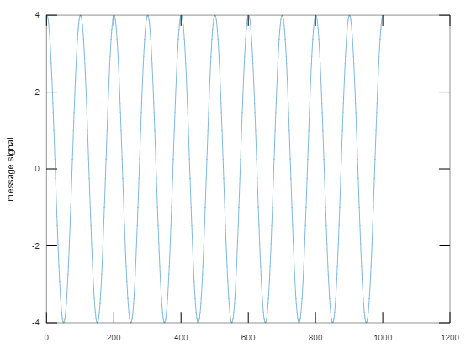

Plot AM signal(Amplitude Modulated signal):

**Am signal is the modified carrier signal**

** Ac >> Fc

t=0:.001:1;

% Plot sine and cosine graph

Am=input("Enter the amplitude of the message signal")

Fm=input("Enter the frequency of the message signal")

m=Am*cos(2*pi*Fm*t)

subplot(3,1,1)

plot(m)

ylabel("message signal")

%xlabel(“time”)

Ac=input("Enter the amplitude of the carrier signal")

Fc=input("Enter the frequency of the carrier signal")

c=Ac*cos(2*pi*Fc*t)

subplot(3,1,2)

plot(c)

ylabel("Carrier signal")

%xlabel(“time”)

AM=(Ac+m).*cos(2*pi*Fc*t);

subplot(3,1,3)

plot(AM)

ylabel("Amplitude Modulated signal")

%xlabel(“time”)plot(m)

ylabel("message signal")

xlabel(“time”)

Ac=input("Enter the amplitude of the carrier signal")

Fc=input("Enter the frequency of the carrier signal")

c=Ac*cos(2*pi*Fc*t)

subplot(3,1,2)

plot(c)

ylabel("Carrier signal")

xlabel(“time”)

** Inputs:(5,10),(5,50)

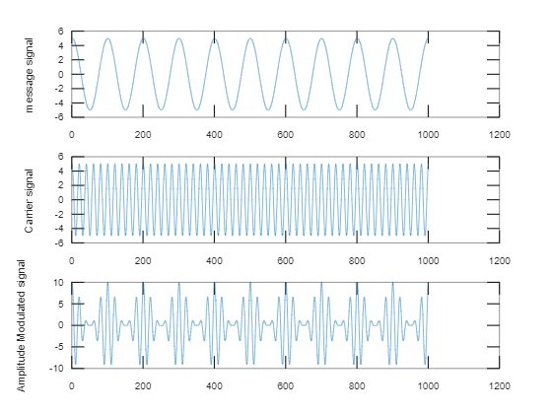

There are three types of modulation:

1. Over modulated (input:(10,5),(100,3))
2. Under modulated (input:(10,5),(100,10))
3. Critically modulated (input:(10,5),(100,5))

**

μ = Am/Ac called modulatation index

Am=Amplitude of message signal

Ac = Amplitude of carrier signal

** If μ < 1 🡪 under modulation

μ = 1 🡪 Critical Modulation

μ > 1 🡪 Over Modulation

we do not prefer u>1 in real life because we have to face

certain distortion(error is happening in the reciver end).So we always prefer μ<=1

code:(same for three of them)

t=0:.001:1;

% Plot sine and cosine graph

Fm=input("Enter the frequency of the message signal")

Am=input("Enter the amplitude of the message signal")

m=Am*cos(2*pi*Fm*t)

subplot(3,1,1)

plot(m)

ylabel("message signal")

%xlabel(“time”)

Fc=input("Enter the frequency of the carrier signal")

Ac=input("Enter the amplitude of the carrier signal")

c=Ac*cos(2*pi*Fc*t)

subplot(3,1,2)

plot(c)

ylabel("Carrier signal")

%xlabel(“time”)

AM=(Ac+m).*cos(2*pi*Fc*t);

subplot(3,1,3)

plot(AM)

ylabel("Amplitude Modulated signal")

%xlabel(“time”)

**Critically modulated(Am=Ac)**

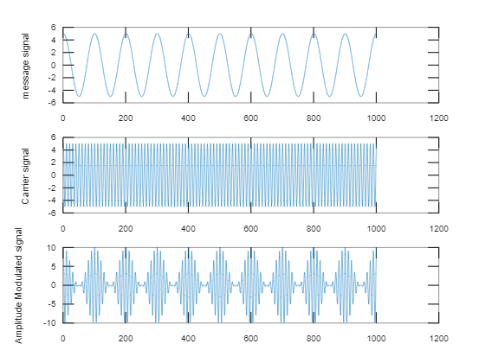

**Under modulated (Am<Ac)**

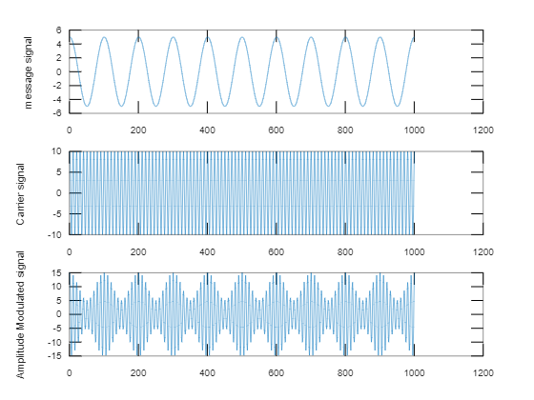

**Over modulated (Am>Ac)**

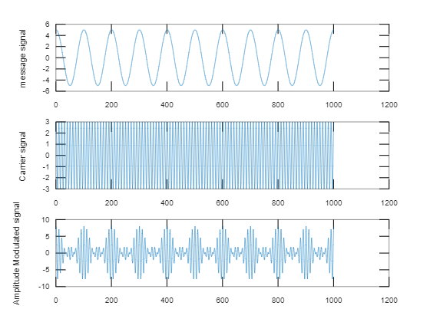

**AM Demodulation**

Input:(10,5),(100,10)

Code:

t=0:.001:1;

% Plot sine and cosine graph

Fm=input("Enter the frequency of the message signal")

Am=input("Enter the amplitude of the message signal")

m=Am*cos(2*pi*Fm*t)

subplot(5,1,1)

plot(m)

ylabel("message signal")

%xlabel(“time”)

Fc=input("Enter the frequency of the carrier signal")

Ac=input("Enter the amplitude of the carrier signal")

c=Ac*cos(2*pi*Fc*t)

subplot(5,1,2)

plot(c)

ylabel("Carrier signal")

%xlabel(“time”)

AM=(Ac+m).*cos(2*pi*Fc*t);

subplot(5,1,3)

plot(AM)

ylabel("Amplitude Modulated signal")

%xlabel(“time”)

DEMOD=AM.*cos(2*pi*Fc*t)

subplot(5,1,4)

plot(DEMOD)

ylabel('Demodulated wave before filtering')

envelope=abs(hilbert(AM))

subplot(5,1,5)

plot(envelope)

ylabel('Demodulated wave after filtering')

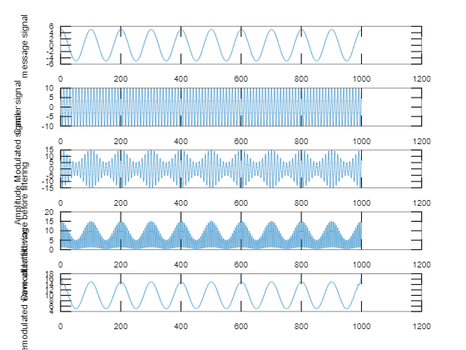

**Experiment-2**

**Experiment of Frequency Modulated Signal**

**Q1) Why we prefer FM over AM ?**

**Ans) Because Noise immunity is very very high.**

Advantages of FM:

1.Less interference and noise

2.Power consumption is less as compared to AM

3.Adjacent FM channels are separated by guard bands.

Disadvantages of FM:

1.Equipment cost is higher and has a large bandwidth.

2.The receiving are of FM signal is small

3.The antennas for FM systems should be kept close for

Better consumtion.

Modulation index of FM is β = k*Am/Wm

If β > wideband FM

Β < Narrowband FM

Code:

t=0:.001:1;

beta = input("enter the value of modulation index")

Fm=input("Enter the frequency of the message signal")

Am=input("Enter the amplitude of the message signal")

m=Am*cos(2*pi*Fm*t)

subplot(3,1,1)

plot(m)

ylabel("message signal")

%xlabel(“time”)

Fc=input("Enter the frequency of the carrier signal")

Ac=input("Enter the amplitude of the carrier signal")

c=Ac*cos(2*pi*Fc*t)

subplot(3,1,2)

plot(c)

ylabel("Carrier signal")

%xlabel(“time”)

FM=Ac*cos(2*pi*Fc*t+beta*sin(2*pi*Fm*t))

subplot(3,1,3)

plot(FM)

ylabel("Frequency modulated signal")

Experiment-3

Study of Generation of Amplitude Shift Keying (ASK) Signal

Encoding techniques:

1. Amplitude shift keying(ASK) (also known as ook=on off keying)
2. Frequency shift keying(FSK)(BFSK= Binary frequency shift keying)
3. Phase shift keying(PSK)

🡪In an ASK system,binary symbol 1 is represented by transmitting carrier wave of fixed amplitude and fixed frequency for the bit duration T second.

🡪The binary symbol 0 will be represented by not transmitting any wave for another bit duration T second.

FSK:

🡪Less susceptible to error than ASK.

🡪used for upto 1200bps on voice grade lines.

🡪high frequency radio

🡪even higher frequency on LANs using co-axial cable

ASK=Input(100,20,5)

Code:

fc=input('Enter the fequency of sive wave carrier');

fp=input('Enter the frequency of peeiodic binary pulse(Messege):');

amp=input('Enter the amplitude (for carrier & binary pulse messege');

t=0:0.001:1;

c=amp.*sin(2*pi*fc*t);

subplot(3,1,1)

plot(t,c)

xlabel('Time')

ylabel('Amplitude')

title('Carrier wave')

m=amp/2.*square(2*pi*fp*t)+(amp/2)

subplot(3,1,2)

plot(t,m)

xlabel('Time')

ylabel('Amplitude')

title('Binary messege pulses')

w=c.*m;

subplot(3,1,3)

plot(t,w)

xlabel('Time')

ylabel('Amplitude')

title('Amplitude shift keyed signal')

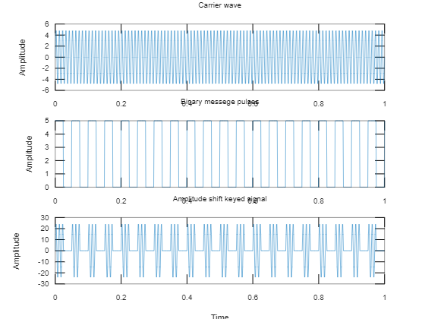

**FSK(Frequency Modulated Signal)**

Input: (!00,50,10,5)

Code:

fc1=input("Enter the frequency of 1st sine wave carrier");

fc2=input("Enter the frequency of 2nd sine wave carrier");

fp=input("Enter the frequency of periodic Binary pulse (Message):");

amp=input("Enter the amplitude (For both carrier & Binary Pulse message");

amp=amp/2

t=0:0.001:1;%for setting the sampling signal

c1=amp.*sin(2*pi*fc1*t);%for generating 1st carrier sine wave

c2=amp.*sin(2*pi*fc2*t);%for generating 2nd carrier sine wave

subplot(4,1,1);

plot(t,c1)

ylabel('Amplitude')

title('Carrier 1 wave')

subplot(4,1,2)

plot(t,c2)

ylabel("Amplitude")

title('carrier 2 wave')

m=amp.*square(2*pi*fp*t)+amp;%for generating square wave message

subplot(4,1,3)

plot(t,m)

ylabel('Amplitude')

title('Binary Message pulses')

for i=0:1000

if m(i+1)==0

mm(i+1)=c2(i+1);

else

mm(i+1)=c1(i+1);

end

end

subplot(4,1,4)

plot(t,mm)

ylabel('Amplitude')

title('Frequency Modulated wave')

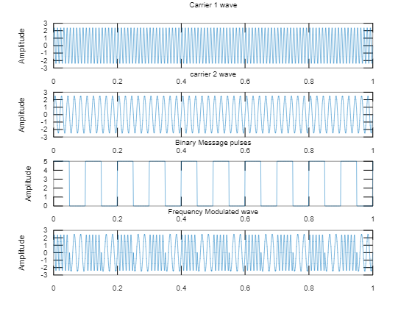

**PSK(Phase shift keying)**

**Input:** [0 1 0 0 1 1 1 0]

Code: clear;

clc;

b = input('Enter the Bit stream \n '); %b = [0 1 0 1 1 1 0];

n = length(b);

t = 0:.01:n;

x = 1:1:(n+1)*100;

for i = 1:n

if (b(i) == 0)

b_p(i) = -1;

else

b_p(i) = 1;

end

for j = i:.1:i+1

bw(x(i*100:(i+1)*100)) = b_p(i);

end

end

bw = bw(100:end);

sint = sin(2*pi*t);

st = bw.*sint;

subplot(3,1,1)

plot(t,bw)

grid on ; axis([0 n -2 +2])

subplot(3,1,2)

plot(t,sint)

grid on ; axis([0 n -2 +2])

subplot(3,1,3)

plot(t,st)

grid on ; axis([0 n -2 +2])

